**Lawrence E. Elkins High School**

**Graduation 2024 FAQ**

**What is the date, time, and location for Graduation?**

Friday, May 24, 2024 at 3:30pm

Fort Bend County Epicenter

28505 Southwest Fwy

Rosenberg, TX 77471

**What time do students need to arrive?**

Students need to arrive for check-in at 2:45pm at the Epicenter. Upon arrival, graduates will enter the designated doors for graduates on the East and West sides of the venue. Graduates will then be directed from the ground level entrance to the staging area.

*\*We will have staff members around the Epicenter to guide graduates where to go*

**What side should I sit on to watch my graduate walk the stage?**

Every seat inside the Epicenter will allow you an optimum view to watch your graduate walk the stage. Seating is first come, first served.

**Where do I park?**

Guests will park and enter at the East or West side doors of the venue lobby. Parking is $5. You can purchase on site or ahead of time (once parking is available for pre-purchase, that information will be emailed to parents and students and posted on the Elkins HS website).

*\*We do anticipate a high number of cars, so please arrive early and carpool if you can.*

**What is the student seating arrangement?**

Top 10 in Numerical Order (1, 2, 3, 4….)

Remaining Top 10% by last name in alphabetical order (A-Z)

All other grads alphabetical order by last name (A-Z)

*Students graduating Summa Cum Laude, Magna Cum Laude, Cum Laude will have this on their graduation walk card and it will be read aloud as they walk across the stage.

**What time can parents enter the Epicenter to find seating?**

Doors will open for seating for guests at 3:00pm. Guests may enter from the East or West side of the lobby doors. Guests will need to go up the stairs upon entering the Epicenter to make their way to the seats. Seating is first come, first serve.

*\*There is an elevator on site*

*\*We highly recommend carpooling as parking will be crowded.*

**What can I bring into the Epicenter?**

Bags up to 4.5”x6.5” in size are permitted into the arena. Clear bags must be no larger than 12”x12”x6. Medical and parenting bags are permitted and are subject to search.

Prohibited bags include, but are not limited to: all purses, bags or containers larger than 4.5”x6.5”, coolers, briefcases, backpacks, fanny packs, cinch bags, luggage of any kind, computer bags, and camera bags. All bags are subject to security search upon entry. This policy is subject to change at any time.

**What can guests/parents bring into the Epicenter?**

Guests may bring small signs, banners, posters and flags may not be larger than 11” by 17” in dimension. Per the EpiCenter guest policies, the following items are prohibited from the venue:

* No alcoholic beverages/illegal drugs
* No outside food or beverages
* No weapons of any kinds or knives
* No items such as confetti, whistles, noisemakers, air horns, laser pointers, etc.
* No glass, plastic, metal containers of any kind (including vases, water bottles, reusable cups, and anything similar)
* No helium balloons, beach balls, banners, flags, oversize posters/signs, or similar items that would block the view of other guests
* No animals of any kind (exceptions for service animals for guests with disabilities)
* No baby seats, carriers, or strollers will be allowed in the guest seating area due to limited available space (Strollers brought into the building will be held in the lobby.)
* No coolers are allowed at the venue (please follow bag policy listed in the FAQs)
* No video recorders, audio recorders, camera/video tripods, selfie sticks, drones, flash photography, or similar items

For a complete list of items that are allowed or prohibited, please visit: <https://www.fortbendisd.com/Page/157883>.

**What can the graduates bring with them?**

Students cannot bring any bags or purses into the Epicenter or hold/carry them with them during the ceremony. Students can bring their phone, but that is all.

**What is the graduate dress code?**

Graduates should arrive with gowns off (all graduates will go through metal detectors upon arrival). No stilettos. Shoes must have a flat sole (wedges are allowed). Graduates must have proper clothing under their gowns. *Caps and gowns should not be decorated in any capacity. Fort Bend ISD does not allow students to walk the stage who have decorated caps and/or gowns.

**What about Stoles, Cords and Medals?**

Graduates can only wear the stoles, cords and/or medals they were given by the school. Students who purchase their own stoles, cords, or medals will not be permitted to wear them during the ceremony.

**Where should I meet my student after the ceremony?**

Following the ceremony, all graduates will leave the venue, exiting the East and West sides. Reunification with your graduate will take place in front of the EpiCenter near the fountain. Graduate last name alpha split signage will be on display around the fountain to better assist families with reuniting with their graduates.

**Will there be a live stream of the graduation to provide to family and friends?**

Yes. Please visit the Fort Bend ISD Graduation Page for the link. It can be found at

<https://www.youtube.com/c/FortBendISDTX>.

**Will there be concessions available during the ceremony?**

Yes, concessions will be open with a limited menu. No outside food or beverages are allowed at the EpiCenter. The EpiCenter is cashless and only accepts major credit and debit cards, along with Apple, Google and Samsung Pay.

**Where can I order graduation photos of my student?**

Yes, guests can take photos from their seats. Guests are not allowed on the arena floor. Only Fort Bend ISD approved photographers are permitted on the arena floor. Guests may not block or stand in the aisles or stairs to take photos. Marc Nathan Photographers, Inc. will capture each graduate’s photo when they receive their diploma cover and after they exit the stage. For more information, please visit <https://www.fortbendisd.com/Page/155605>.

**Where can I find a copy of my graduate’s commencement program?**

Digital programs for each graduation will also be linked below on the day of each graduation at <https://www.fortbendisd.com/Page/155605>.

**When will my graduate be able to pick up their diploma?**

Graduates will receive a diploma cover at the commencement ceremony. Diploma certificates will be delivered to the high school later in June. Each campus will send out information to parents and graduates when the diploma certificates are available for pickup. Note: A student’s transcript is the official documentation of graduation.

**Important Websites**

Fort Bend ISD Graduation Home Page – <https://www.fortbendisd.com/Page/106851>

Fort Bend ISD Graduation FAQ Page – <https://www.fortbendisd.com/Page/157880>

Fort Bend ISD Graduation Live Streams, Digital Programs, and Graduation Photo Ordering – <https://www.fortbendisd.com/Page/155605>

Epicenter Information Page – <https://thefortbendepicenter.com/plan-your-visit/a-z-guide/#:~:text=Fort%20Bend%20Epicenter%20encourages%20guests,are%20permitted%20into%20the%20arena>.

**Miscellaneous**

No tickets are required to enter the ceremony. No transportation will be provided to graduates.

Graduates must be in a cap and gown to walk in the commencement ceremony.

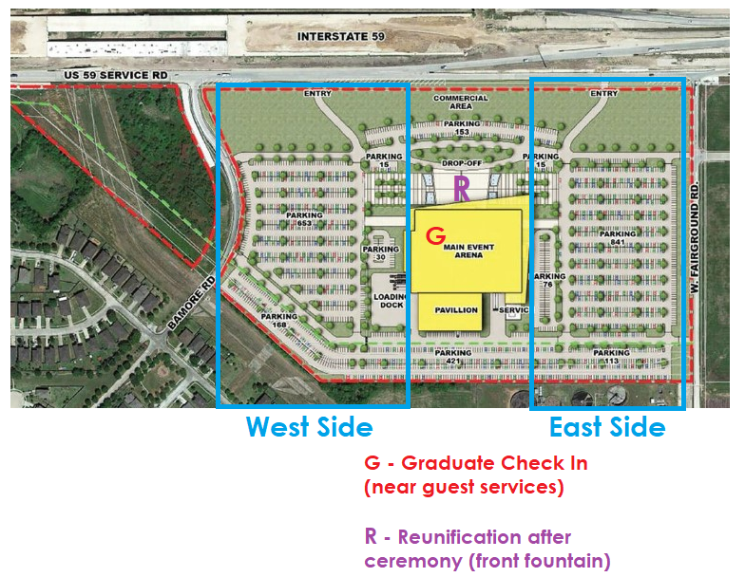**Map of Epicenter**